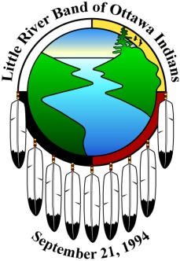

**Little River Band of Ottawa Indians**

**Binojeeuk Commission**

**Administration Office**

**2608 Government Center Dr.**

**Manistee, MI 49660**

**2021 BINOJEEUK CALENDER**

**July 6, 2021**

**July 20, 2021**

**August 3, 2021**

**August 17, 2021**

**September 7, 2021**

**September 21, 2021**

**October 5, 2021**

**October 19, 2021**

**November 2, 2021**

**November 16, 2021**

**December 7, 2021**

**December 21, 2021**

**January 5, 2021**

**January 19, 2021**

**February 2, 2021**

**February 16, 2021**

**March 2, 2021**

**March 16, 2021**

**April 6, 2021**

**April 20, 2021**

**May 4, 2021**

**May 18, 2021**

**June 1, 2021**

**June 15, 2021**

**BINOJEEUK Meetings -1:00 p.m.**

**Family Services Department Conference Room**