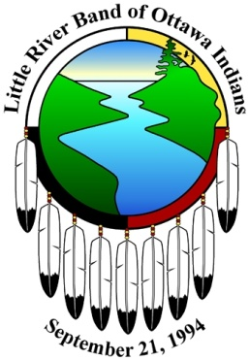

## Gaa Ching Ziibi Daawaa Anishinaabek

# Little River Band of Ottawa Indians

2608 Government Center Drive

Manistee, MI 49660

# Tribal Council

0

February 23, 2022

Lori Shustha Council Director, GVAIL

401 Ferris N.W

Grand Rapids MI 49544

616-364-4697

[wabushna@yahoo.com](mailto:wabushna@yahoo.com)

RE: Donation Request

Dear Lori,

On October 27th, 2021, the Little River Band of Ottawa Indians Tribal Council adopted a new charitable donations ordinance. This ordinance supports donation to any American Indian controlled 501c3 charitable organization that is in good standing with their designation from the Internal Revenue Service.

Unfortunately, LRBOI Tribal Council cannot accommodate your request for a donation with the belief that the ordinance criteria has not been met. If you feel that you meet this qualification, please re-submit a Charitable Donation Request Form with the necessary documentation and we will suggest a reconsideration. If you have any questions, feel free to contact the Tribal Council Recorder at the number provided below. You may send your organizations information to:

Little River Band of Ottawa Indians Tribal Council Recorder

Attn: Charitable Contributions

2608 Government Center Drive

Manistee, Michigan  49660

231-723-8288

Thank you for your interest.

Sincerely,

Venus Wilson-Torres

LRBOI Tribal Council Legislative Director